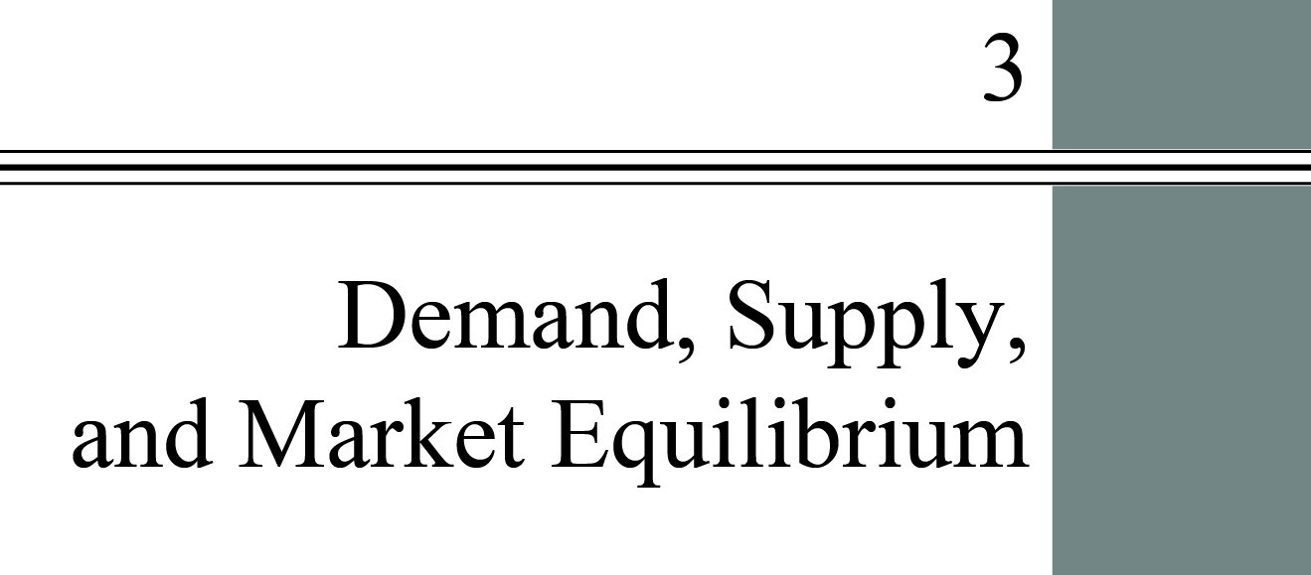

**Chapter Outline**

**Firms and Households: The Basic Decision-Making Units**

Understand the roles of firms, entrepreneurs, and households in the market.

**Input Markets and Output Markets: The Circular Flow**

Understand the role of households as both suppliers to firms and buyers of what firms produce.

**Demand in Product/Output Markets**

Understand what determines the position and shape of the demand curve and what factors move you along a demand curve and what factors shift the demand curve.

**Supply in Product/Output Markets**

Be able to distinguish between forces that shift a supply curve and changes that cause a movement along a supply curve.

**Market Equilibrium**

Be able to explain how a market that is not in equilibrium responds to restore an equilibrium.

**Demand and Supply in Product Markets: A Review**

detailed chapter Outline

I. Introduction

This chapter and the next discuss how markets work. Taken together they explain how individual and household decisions about demand and firms’ decisions about supply interact. As Adam Smith pointed out, this coordination happens without any central planning or direction. Markets and prices answer the three basic questions of what to produce, how to produce, and who will get what is produced.

II. Firms and Households: The Basic Decision-Making Units

A. The two fundamental decision-making units in the economy are firms and households.

B. A *firm*is an organization comes into being when a person or a group of people decides to produce a good or service to meet a perceived demand. Firms are the primary producing units in a market economy.

1. A firm exists when a person or group of people decides to produce something.

2. Firms transform inputs (resources) into outputs (goods and/or services).

3. Firms can be large or small or in-between.

4. Most firms exist to make a profit for their owners.

a. Not-for-profit organizations include many colleges and universities as well as groups such as the Red Cross.

b. The text makes the standard assumption that businesses make decisions with the intention of maximizing profits.

C. An *entrepreneur*is a person who organizes, manages, and assumes the risks of a firm, taking a new idea or a new product and turning it into a successful business.

D*. Households* are the consuming units in an economy. Their decisions are based on their tastes and preferences and are constrained by their limited incomes and prices.

**Unique *Economics in Practice***

How big are U.S. businesses? The U.S. Bureau of the Census publishes “Statistics of U.S. Businesses” every year (https://www.census.gov/programs-surveys/susb/about.html). As of late 2018, the most recent year covered is 2015.

In 2015 there were 5.9 million businesses in the United States employing 124.1 million workers. The average was 21.0 workers per firm. Looking at firms with between 1 and 4 workers, there were 3.6 million firms with 5.9 million employees, an average of 1.61. In other words, these very small firms were 61.8 percent of total firms with 4.7 percent of all employees. There are a very large number of very small businesses in the United States.

At the other end of the spectrum are businesses with 500 or more employees. There were 19,464 firms with 65,147,800 employees. Average employment in each firm was 3,347.1. These enterprises were a measly 0.33 percent of the total number of firms but they employed 52.5 percent of all workers.

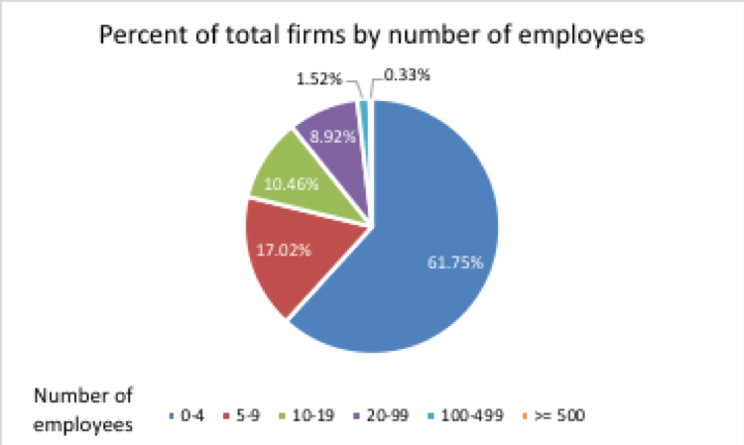

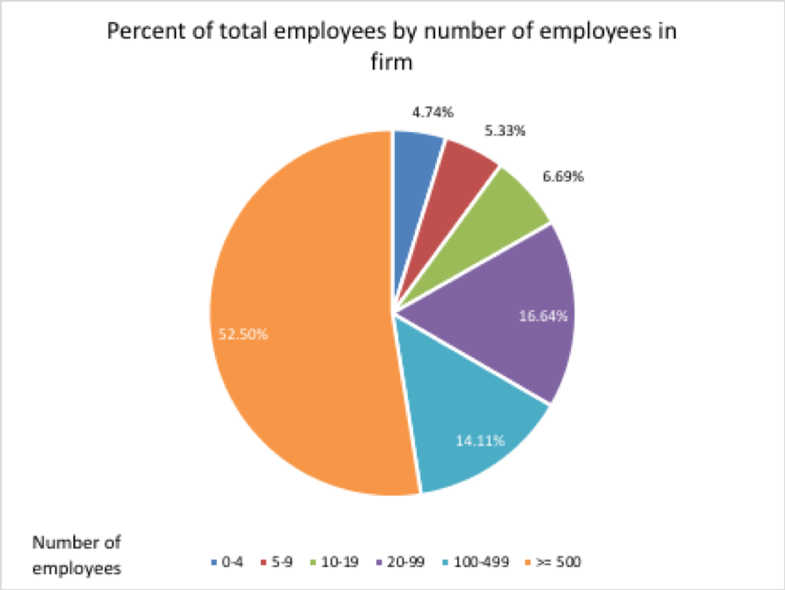

Question: Why are there so many small businesses? And why do large businesses get so big?

Answer: All businesses start as small businesses. Microsoft famously was started by Bill Gates and Paul Allen while they were students at Harvard. Steve Jobs, Steve Wozniak, and Ronald Wayne started Apple in a garage in Los Altos. In many cases, entrepreneurs start small businesses hoping some day they will become big businesses. In other cases, staying small is desirable for a business owner. You can set your own hours, your only boss is yourself, and you’re independent. Staying small is as much a lifestyle choice as it is a business decision.

III. Input Markets and Output Markets: The Circular Flow

A. Households and firms interact in both input and output markets.

1. To produce goods and services firms must buy resources in *input* or *factor markets*, the markets in which resources used to produce goods and services are exchanged. Firms buy or rent these inputs from households who own them. These resources are used to produce output which is sold in *output markets*.*Product*or *output markets*are the markets in which goods and services are exchanged.

2. The *labor market* is the input/factor market in which households supply work for wages to firms that demand labor. Most households earn much of their income by supplying labor in this market.

3. The *capital market* is the input/factor market in which households supply their savings, for interest or for claims to future profits, to firms that demand funds to buy capital goods.

4. The *land market* is the input/factor market in which households supply land or other real property in exchange for rent.

5. *Factors of production* are the inputs into the production process. Land, labor, and capital are the three key factors of production. The general name for the labor, capital, land, and other inputs supplied by households is *input markets* or *factor markets*.

B. The circular flow implies that national income must equal national product.

IV. Demand in Product/Output Markets

A. A household’s decision about what quantity of a particular product to purchase depends on:

1. The *price of the product*.

2. The *income available* to the household.

3. The household’s *amount of accumulated net wealth*.

4. The *prices of other products* available to the household.

5. The household’s *tastes and preferences*.

6. The household’s *expectations* about future income, wealth, and prices.

7. *Quantity demanded* is the amount (number of units) of a product that a household would buy in a given period *if it could buy all it wanted at the current market price*.

a. Emphasize the important role of time. Quantity demanded is a flow.

b. A change in quantity demanded assumes every other factor affecting demand is held constant (*Ceteris paribus*).

B. Changes in Quantity Demanded versus Changes in Demand

1. A change in the price of the product changes *quantity demanded* per period. Only a change in price can cause a movement along a demand curve. This is the most important relationship in any market.

2. A change in any other factor affecting demand, such as income or preferences, affects *demand*. Changes in demand cause the demand curve to shift.

C. Price and Quantity Demanded: The Law of Demand

1. A *demand schedule* shows how much of a given product a household would be willing to buy at different prices for a given time period. A *demand curve* is a graph illustrating how much of a given product a household would be willing to buy at different prices. In other words a demand curve is a graph of a demand schedule.

2. Demand Curves Slope Downward

a. The *law of demand* is the negative relationship between price and quantity demanded: *Ceteris paribus*, as price rises, quantity demanded decreases; as price falls, quantity demanded increases during a given period of time, all other things remaining constant.

b. This is reasonable given that consumers have limited income; as the price of one product rises, the household will have less to spend on other products.

c. Also at work is the *law of diminishing marginal utility*: If successive units are worth less to the consumer, the person will not be willing to pay as much for them. (*Utility* is the satisfaction a consumer receives from consuming a good or service. *Marginal utility* is the change in total satisfaction when one more unit of a product is consumed.)

3. Other Properties of Demand Curves

a. They have a negative slope.

b. Most demand curves intersect the price (y) axis somewhere. There is a maximum price a household (or an entire market) is willing and able to pay for any product.

c. Most demand curves also intersect the quantity axis. Even if you give the product away there is a limit to the quantity that will be consumed.

D. Other Determinants of Household Demand

1. Income and Wealth

a. *Income* is the sum of all a household’s wages, salaries, profits, interest payments, rents, and other forms of earnings in a given period of time. It is a flow measure.

b. *Wealth* or *net worth* is the total value of what a household owns minus what it owes. It is a stock measure.

c. Higher income usually causes a household to buy more things. *Normal goods* are goods for which demand goes up when income is higher and for which demand goes down when income is lower. *Inferior goods* are goods for which demand tends to fall when income rises.

d. Higher wealth also usually causes a household to buy more things.

2. Prices of Other Goods and Services

a. *Substitutes* are goods that can serve as replacements for one another; when the price of one increases, demand for the other increases. *Perfect substitutes* are identical products. If an increase in the price of good A causes the demand for good B to increase (and vice versa) the goods are substitutes.

b. *Complements* or *complementary goods* are goods that “go together”; a decrease in the price of one results in an increase in demand for the other and vice versa. If an increase in the price of good X results in a decrease in the demand for good Y (and vice versa) the goods are complements.

3. Tastes and Preferences

a. As households have a greater preference for a product they buy more of it.

b. Some products are sold based on fad or fashion.

c. One interesting question is why some markets exhibit product diversity while others do not. There are many, many types of wine but only two

4. Expectations

a. Your beliefs about future income or prices will affect your current purchasing decisions.

b. People sometimes mistakenly think certain demand curves slope upward. They are confusing a change in quantity demanded with a change in demand caused by expectations of higher prices in the future.

**Unique *Economics in Practice***

There are substitutes for the “dead tree” editions of textbooks. Electronic versions of most textbooks are available today. Many textbook publishers offer e-book versions of many of their books. One interesting independent company,VitalSource.com, will rent you an e-book for 180 days at a fraction of the retail price (<http://www.vitalsource.com>). VitalSource offers apps for mobile devices that let you download the textbook onto your mobile device.

For those who want to stick with the hardcopy version, many bookstores (and publishers) offer to rent you the textbook. This is, of course, a substitute for the ever-popular book buyback at the end of each academic term. Instead of selling your books back to the bookstore, you just turn them in.

A popular source for reduced-price textbooks is <http://www.amazon.uk>. Textbook publishers sell almost identical versions of their books in Europe at much lower prices. The U.K. is popular because the books are written in English. This is a form of arbitrage.

And, of course, there are less legal substitutes. Most textbooks are available as pdf files somewhere on the internet.

Question: There is obviously competition in this market. What effect is increased competition likely to have on the price of books offered as e-books? What effect will that have on the price of paper books?

Answer: More competition generally means lower prices. Distribution costs for e-books are virtually zero. Since paper books are substitutes for e-books it’s safe to predict that prices of paper books will also fall.

E. Shift of Demand versus Movement along a Demand Curve

1. When any of the other factors change, a new relationship between price and quantity is established. This is a shift of the demand curve. A *shift of a demand curve* is the change that takes place in a demand curve corresponding to a new relationship between quantity demanded of a good and price of that good. The shift is brought about by a change in the original conditions.

2. Price changes cause the quantity demanded to change. This is a movement along a demand curve. A *movement along a demand curve* is the change in quantity demanded brought about by a change in price.

F. From Household Demand to Market Demand

1. *Market demand* is the sum of all the quantities of a good or service demanded per period by all the households buying in the market for that good or service.

2. Economists do not actually add up individual demand curves to derive a market demand curve. Instead we use data from the entire market to statistically estimate a demand curve.

V. Supply in Product/Output Markets

A. Introduction

Supply decisions depend on profit potential. *Profit* is the difference between total revenue and total cost. Revenue is price per unit times the number of units sold. Total revenue depends on the price of the firm’s product in the market and how much it can sell. Cost depends on the inputs needed to produce the product, the quantity of each input the firm uses, and the price of each input.

B. Price and Quantity Supplied: The Law of Supply

1. *Quantity supplied* is the amount of a particular product that a firm would be willing and able to offer for sale at a particular price during a given time period.

2. A *supply schedule* shows how much of a product firms will sell at alternative prices.

3. The *law of supply* is the positive relationship between price and quantity of a good supplied: An increase in market price *ceteris paribus* will lead to an increase in quantity supplied, and a decrease in market price will lead to a decrease in quantity supplied.

4. A *supply curve* is a graph illustrating how much of a product a firm will sell at different prices. A supply curve is a graph of the supply schedule. The upward slope of the supply curve reflects the positive relationship between price and quantity supplied.

C. Other Determinants of Supply

1. The Cost of Production

a. Per unit cost depends on a number of factors, including the available technologies and the prices of the inputs needed.

b. When a technological advance lowers the cost of production, output is likely to increase. The supply curve shifts outward.

c. An increase in the price of a variable input that’s a significant fraction of production costs will cause the supply curve to shift inward.

2. The Prices of Related Products

a. If land can be used for corn or soybean production, an increase in the price of one crop can cause farmers to produce more of that crop and decrease the amount supplied of the other.

b. When an increase in the price of one product causes decreased production of another product, the two are *substitutes in production*.

c. There are also *complements in production*. An increase in the price of beef will induce ranchers to increase the quantity of beef supplied. There will also be more leather produced from the cowhides.

D. Shift of Supply versus Movement along a Supply Curve

1. The supply curve is derived holding everything constant except the price of the product (*ceteris paribus*). A *movement along a supply curve* is the change in quantity supplied brought about by a change in price. When the price of a product changes, a change in the quantity supplied follows and a movement along the supply curve takes place. This is called a change in quantity supplied.

2. If any other factor affecting supply changes there will be a new relationship between price and quantity supplied. A *shift of a supply curve* is the change that takes place in a supply curve corresponding to a new relationship between quantity supplied of a good and the price of that good. The shift is brought about by a change in the original conditions. This is called a change in supply.

E. From Individual Supply to Market Supply

1. *Market supply* is the sum of all that is supplied each period by all producers of a single product.

2. The market supply curve also shifts when there is a change in the number of

VI. Market Equilibrium

A. Introduction

The operation of the market depends on the interaction between buyers and sellers. *Equilibrium* is the condition that exists when quantity supplied and quantity demanded are equal. At equilibrium, there is no tendency for price to change. This holds as long as neither the supply nor the demand curve shifts.

B. *Excess demand* or *shortage* is the condition that exists when quantity demanded exceeds quantity supplied at the current price. The price will increase until the shortage is eliminated. This is the process of *price rationing*: Price increases will distribute what is available to those who are willing and able to pay the most. The higher price will also induce some sellers to increase the quantity supplied.

C. *Excess supply*or *surplus* is the condition that exists when quantity supplied exceeds quantity demanded at the current price. The price will decrease until the surplus is eliminated.

D. Market Equilibrium with Equations

1. Invert the demand curve *Qd* = 14 – 2*P*

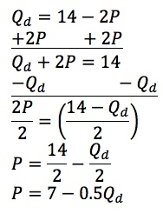

2. Invert the supply curve Qs = 2 + 4P

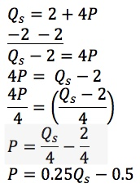

3. In equilibrium, the price must be the same for both demand and supply. Also quantity supplied must equal quantity demanded.

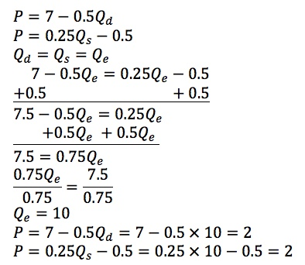

E. Changes in equilibrium occur when the supply curve or demand curve shifts. These shifts can create temporary shortages and surpluses and result in price changes.

**Unique *Economics in Practice***

Does raising the minimum wage increase unemployment? Basic economic theory says that if the minimum wage is higher than the equilibrium wage, there will be a surplus of labor. We commonly refer to that as unemployment. A 2011 study by William Even (Miami University) and David Macpherson (Trinity University) looked at 600,000 observations from 1994 to 2010. The data includes “robust sample of minority young adults unprecedented in previous studies on the minimum wage.” The authors used the natural experiment of differences in minimum wages among states and focused on 16- to 24-year-old males without a high school diploma.

Even and Macpherson conclude that a 10 percent increase in the minimum wage decreased employment by 2.5 percent for white males; 1.2 percent for Hispanic males; and 6.5 percent for black males. There were similar impacts on hours worked in each group.

Occupational choice seems to explain most of the difference. Almost 1/3 of the black men in this group were employed in eating and drinking places. This industry is especially vulnerable to changes in costs. And there is significant regional variation caused by young black adults overwhelmingly being located in the South and urban areas.

Question: Despite any number of studies giving similar results, some economists still favor raising the minimum wage. Why?

Answer: These economists are making a normative judgment that the increased income earned by those who keep their jobs outweighs the harm done to those who lose their jobs. This is a value judgment, not positive economic analysis.

Sources: Even, William E and David A. Macpherson, “The Effect of the Tipped Minimum Wage on Employees in the U.S. Restaurant Industry.” *Southern Economic Journal* 2014, 80(3),   
633–655.

Even, William E and David A. Macpherson, “ Unequal Harm: Racial Disparities in the Employment Consequences of Minimum Wage Increases.” Employment Policy Institute,   
May 2011.

VII. Demand and Supply in Product Markets: A Review

This chapter has considered the basic way that the forces of supply and demand operate in free markets. This section summarizes the important points.

Extended Applications



Application 1: Supply and Demand in Energy Markets

During the late 1980s, many East Coast colleges purchased expensive equipment to enable them to switch rapidly from oil to natural gas in the event of a sudden oil price increase. In fall 1990, after Iraq invaded Kuwait and oil prices skyrocketed, the colleges put their new equipment to use. But when college administrators received bills from their local utility companies, they found that the price of natural gas had risen as well! Many of these administrators were surprised and angry at the utility companies, accusing them of “gouging” the public. The invasion of Kuwait did not threaten natural gas supplies, they reasoned, so there was no logical reason for a natural gas price hike. Why did the price of oil rise after Iraq’s invasion of Kuwait? Why did the price of natural gas rise? Were the administrators correct in their outrage?

Oil prices rose dramatically immediately after Iraq’s invasion of Kuwait, well before there was any actual disruption of oil supplies to the world market (it takes weeks for disruptions at the wellhead to impact oil deliveries to consuming nations). Thus, it would be incorrect to believe that oil prices rose because of a shift in the supply curve. In fact, the reason for the price change was a change in expectations: Buyers anticipated that supplies to oil-consuming nations might become disrupted in the future, which would cause a future rise in prices. This, in turn, caused speculators to increase their demand for oil, and the demand curve shifted rightward (see the diagram), causing oil prices to rise well before any supply shift occurred.



As for the colleges, the administrators may have made a serious mistake by ignoring the relationship between the oil market and the natural gas market. Natural gas is a substitute for oil. When the price of oil rises, many buyers—not just a few colleges—switch to natural gas as a source of energy. Although utilities buy some of their natural gas in a regulated market where state governments set the price, they also buy gas in unregulated markets where the price is set by supply and demand. When the utility companies increased their demand for natural gas in these unregulated markets, the demand curve for natural gas shifted rightward, and the price paid by the utility companies rose accordingly (see diagram). The utilities then passed on this price increase to their customers. (Many utilities, particularly in California, had switched from oil to natural gas because the latter generated less pollution.)

Had college administrators correctly understood the relationship between oil and natural gas prices, they might have decided that their expensive switching equipment was not a good investment. Perhaps the money could have been better spent on insulation for dorm rooms or on other energy-conserving measures.

Application 2: The Price of Lettuce

There are three main categories of lettuce sold in the United States: head lettuce (usually iceberg lettuce), leaf lettuce (red or green leaf) and romaine lettuce. About 75 percent of U.S. lettuce production is grown in California, with the remaining 25 percent from Arizona. As you might expect, one of the key inputs to lettuce production is water.

In California, the year 2013 was the driest year since the state started keeping records in 1850. As the drought continued through 2014, state residents managed to cut water use by 27 percent. Farmers were especially hard-hit. Some received a total allocation of zero. While there is a market for water, it is small relative to total use, making it difficult for farmers and households to simply acquire more.

You may be asking, “What does this have to do with me?” Maybe quite a bit. In 2014 California produced 74.3 percent of all the lettuce grown in the United States. The remaining 25.7 percent was grown in Arizona. The drought reduced U.S. production. In 2013 California grew 6.5 billion pounds of lettuce. In 2014 the total was 6.1 billion pounds. For the entire U.S. production fell from 8.4 billion pounds to 8.2 billion pounds.

Faced with this decrease in domestic supply, the price per pound rose from $0.26 per pound in 2009 to $0.27 per pound in 2014. The price spiked in 2013 at $0.28. (These prices are adjusted for inflation.) But the price increase in 2013 had a beneficial effect. Imports grew by about 40 million tons between 2013 and 2014. In 2009 U.S. imports were 292 million pounds, rising to 446 million pounds in 2014.

Mexico has benefited tremendously from the drought. In 2009 Mexico supplied 0.75 percent of U.S. consumption. That percentage increased to 1.64 percent in 2013 then dropped slightly to 1.42 percent in 2014. And Mexico’s share of total U.S. imports rose from 21 percent in 2009 to 25 percent in 2014, again with a spike to 33 percent in 2013.

In other words, international trade helped mitigate the impact of the drought. Putting this another way, between 2013 and 2014, U.S. production fell by 232 million pounds, but consumption only decreased by 163 million pounds. This was offset by higher imports (40 million pounds) and lower exports (–29 million pounds). The higher domestic price induced greater imports and also gave domestic producers more of an incentive to sell to the domestic market instead of exporting.

One simple graph tells most of the story:

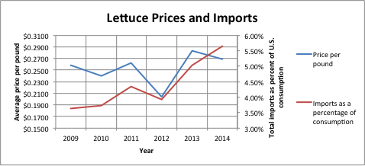

Sources:

Data for Tables 26 and 27 is from the U.S. Department of Agriculture “Vegetables and Pulses Yearbook.”

State-by-state data is from Cornell University’s USDA database at <http://usda.mannlib.cornell.edu/>.

Official California state drought site: <http://ca.gov/drought/>.

Rogers, Paul (2014). “California drought: Past dry periods have lasted more than 200 years, scientists say.” San Jose Mercury-News, January 25, 2014.